Report Title:

“Online Health Consultation System”

By “Aliza Noreen”

ACKNOWLEDGEMENT
We wish to express our deepest gratitude to Course Instructor Dr. Waqar Ashraf Khan who guided us on every step of making this project. It is whole-heartedly appreciated that your great advice for our project proved monumental towards the success and cooperation of this project.
We would like to express our gratitude towards our parents & friends for their kind cooperation and encouragement which help us in completion of this project.
Our thanks and appreciations also go to our colleagues in developing the project and people who have willingly helped us out with their abilities.

ABSTRACT
This Online Health Consultation System (HCS) is a web-based application designed to digitalize and streamline healthcare operations, enhancing efficiency in patient registration, appointment scheduling, and billing. By replacing manual paper-based processes, the system provides secure data management for patient records, doctor availability, and medical history, minimizing human error. Key modules include user-friendly interfaces for administration, receptionist tasks, and patient interactions. Developed using modern technologies, this robust system ensures high-speed data retrieval and secure user authentication to maintain data confidentiality. The final system aims to improve overall hospital management, improve patient care, and reduce administrative costs

CONTENTS
DECLARATION iii
CERTIFICATE iv
ACKNOWLEDGEMENT v
ABSTRACT vi
CONTENTS 7
LIST OF FIGURES 8
LIST OF TABLES 9
1 CHAPTER-01: INTRODUCTION 10
2 CHAPTER-02: DATABASE DESIGN 12
3 CHAPTER-03: SYSTEM DESIGN & IMPLEMENTATION 16
4 CHAPTER-04: SYSTEM FEATURES 26
5 CHAPTER-05: SYSTEM WORKING 31
6 CHAPTER-06: SECURITY & FUTURE IMPROVEMENTS 34
7 CHAPTER-07: CONCLUSION 35

LIST OF FIGURES
Figure 1.1 ................................................…………………………………. Home Page of HMS
Figure 1.2 ...............................................………………………………….. Patient Dashboard
Figure 1.3 ..................................................……………………………….. Doctor Dashboard
Figure 1.4 ..................................................……………………………….. Receptionist Dashboard
Figure 2.1 ..................................................……………………………….. Database Structure
Figure 2.2 ..................................................……………………………….. ER Diagram
Figure 3.1 ..................................................……………………………….. Main Registration Page
Figure 3.2 ..................................................……………………………….. Patient Login Page
Figure 3.3 .................................................……………………………….. . Doctor Login Page
Figure 3.4 .................................................……………………………….. . Patient Dashboard Interface
Figure 3.5 ..................................................……………………………….. Doctor Dashboard Interface
Figure 3.6 ......….............................……………………………….. Receptionist Dashboard Interface
Figure 3.7 ..................................................………………………….. Backend Logic Implementation
Figure 3.8 ..................................................……………………………….. Prescription Form Page
Figure 3.10 .................................................……………………………….. Logout Page
Figure 3.11 .................................................……………………………….. Login Error Page
Figure 4.1 .................................................. ……………………………….. Appointment Booking Form
Figure 4.2 .................................................……………………………….. . Appointment History
Figure 4.3 ...............................................……………………………….. ... Doctor Appointment Panel
Figure 4.4 .........................................……………………………….. ......... Doctor Prescription List
Figure 4.5 ........................................……………………………….. .......... Receptionist Doctor Management
Figure 4.6 .......................................……………………………….. .......... Queries Management Page
Figure 5.1 .....................................………………………............. Appointment Booking Workflow
Figure 5.2 ......................................……………………………….. ............ Generated PDF Report

LIST OF TABLES
Table 1.1 ........................................................................................... Technologies Used in the System
Table 2.1 .................................................................................................. Structure of patreg Table
Table 2.2 .................................................................................................. Structure of doctb Table
Table 2.3 ............................................................................................ Structure of appointmenttb Table
Table 2.4 .................................................................................................. Structure of prestb Table
Table 2.5 .................................................................................................. Structure of admintb Table
Table 2.6 .................................................................................................. Structure of contact Table

- CHAPTER-01: INTRODUCTION
  - Introduction

The Global Hospital Management System (HMS) is a web-based application built using PHP, MySQL, Bootstrap 4, HTML, CSS, and JavaScript. The purpose of this project is to digitize and manage the daily operations of a hospital — including patient registration, appointment booking, doctor management, prescription writing, and bill generation.
The system has three types of users — Patient, Doctor, and Admin— each with their own login and dashboard. This makes sure that the right people have access to the right features.

  - Project Objectives
- Allow patients to register, login, and book appointments with doctors
- Allow patients to describe their symptoms when booking an appointment
- Enable doctors to view appointments along with patient symptoms
- Allow doctors to write prescriptions for their patients
- Allow receptionists to manage doctors, view patients and appointments
- Generate a professional PDF bill after treatment
- Provide a clean and easy-to-use interface for all users

  - Technologies Used:

Technology | Purpose
PHP | Server-side logic and back-end processing
MySQL | Database to store all hospital data
Bootstrap 4 | Responsive and clean UI design
HTML / CSS | Page structure and custom styling
JavaScript | Client-side validation and interactivity
TCPDF Library | Generating PDF bills for patients
jQuery | DOM manipulation and Bootstrap JS support
Font Awesome | Icons used throughout the application
IBM Plex Sans | Google Font used for typography
Table 1.1: Technologies Used in the System

  - System Users and Portals:

The system is divided into three portals:

1.4.1 Patient Portal
- Login Page: index1.php
- Dashboard: admin-panel.php
- Patients can register on index.php and login on index1.php
- After login, patients are taken to their dashboard

1.4.2 Doctor Portal
- Login Page: index2.php
- Dashboard: doctor-panel.php
- Doctors can register on index.php (Doctor tab) and login on index2.php
- After login, doctors can see their appointments and patient details

1.4.3 Receptionist Portal
- Login Page: index.php (Receptionist tab)
- Dashboard: admin-panel1.php
- Receptionist logs in using username and password stored in admintb table

- CHAPTER-02: DATABASE DESIGN

2.1 Database Overview:

Database Name: “myhmsdb”

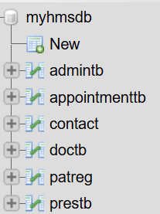
Figure 2.1: Database Structure of myhmsdb

2.2 Patient Registration Table (patreg):

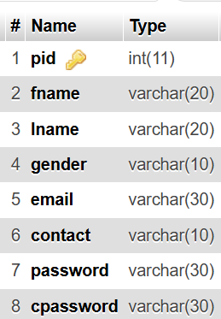

Table 2.1: Structure of patreg Table

2.3 Doctor Table (doctb):

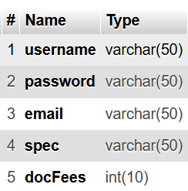

Table 2.2: Structure of doctb Table

2.4 Appointment Table (appointmenttb):

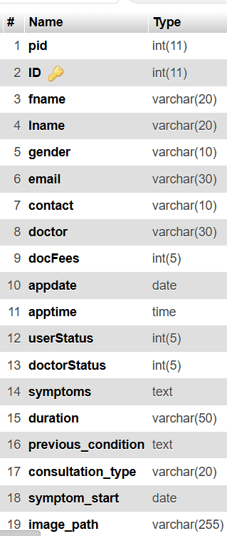

Table 2.3: Structure of appointmenttb Table

2.5 Prescription Table (prestb):

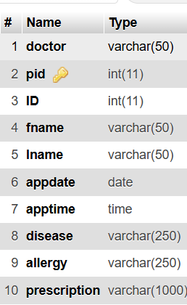
Table 2.4: Structure of prestb Table

2.6 Admin Table (admintb):

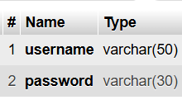
Table 2.5: Structure of admintb Table

2.7 Contact Table (contact)

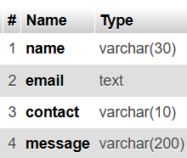

Table 2.6: Structure of contact Table

2.8 ER Diagram

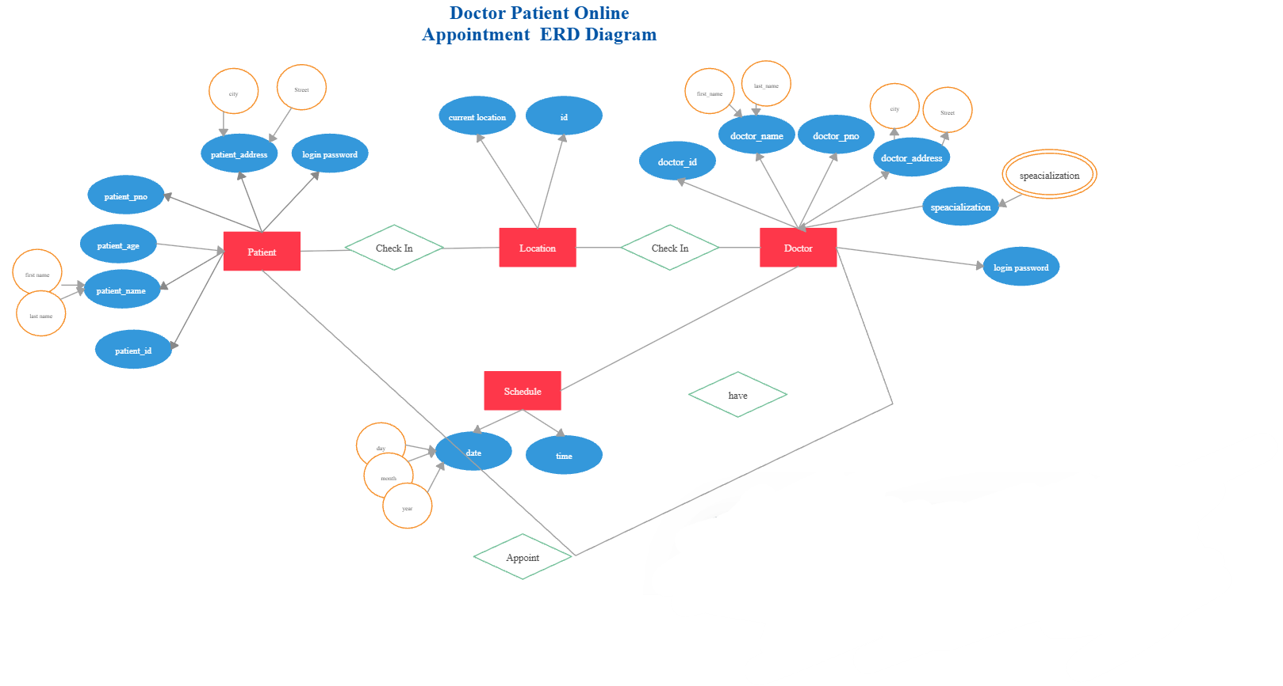
Figure 2.7: Entity Relationship Diagram of HMS

- CHAPTER-03: SYSTEM DESIGN & IMPLEMENTATIN
3.1 Main Pages:

- front.html & index.php— First Landing page to get started
This is the first page of the system.

- index.php— main registration page
Where user can register based on role

- index1.php — Patient Login Page
A dedicated login page for patients. The patient enters their email and password. The form submits to func.php which checks the credentials and redirects to the patient dashboard.
Main registration page
- index2.php — Doctor Login Page:

A dedicated login page for doctors. The doctor enters their username (full name) and password. The form submits to func1.php which checks the credentials and redirects to the doctor dashboard.






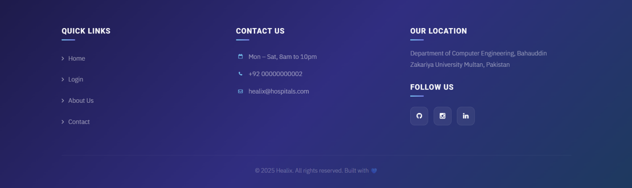

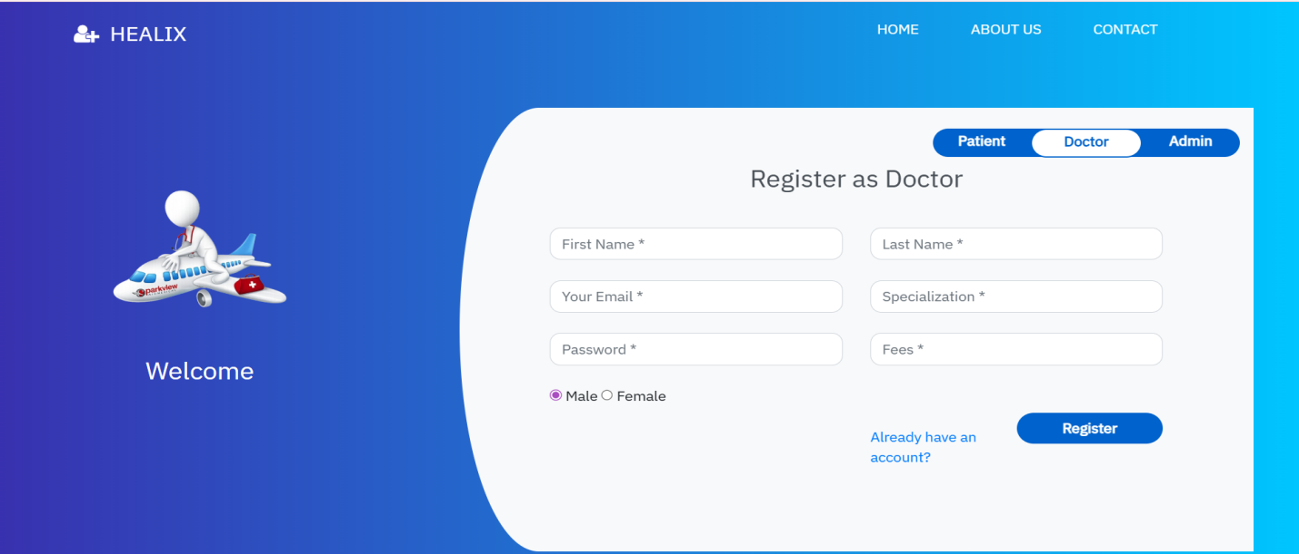
Figure 3.1: Main Registration Page

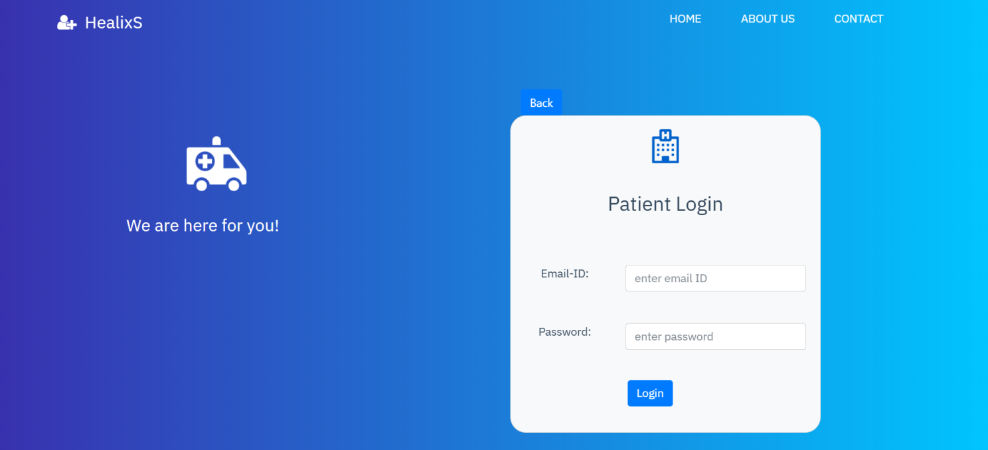
Figure 3.2: Patient Login Page

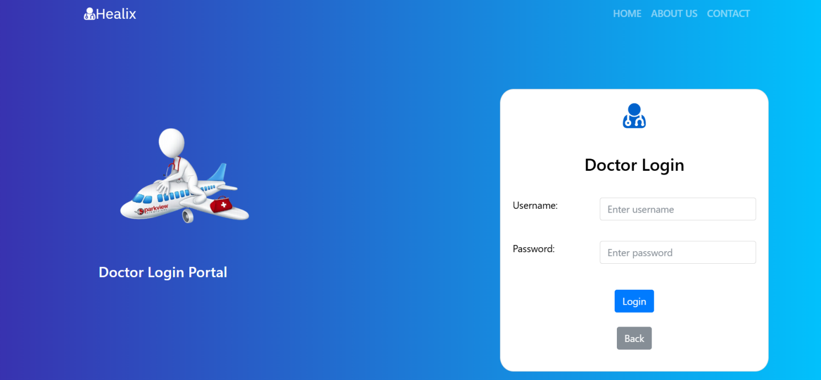
Figure 3.3: Doctor Login Page

3.2 Dashboard Pages:

- admin-panel.php — Patient Dashboard
- This is the main dashboard for logged-in patients. It has four sections:
- Dashboard: quick links to other sections
- Book Appointment: full form to select doctor, date, time, symptoms, consultation type, and upload image
- Appointment History: shows all appointments with status and cancel option
- Prescriptions: shows prescriptions from doctors and allows bill payment (PDF generation)

- admin-panel1.php — Admin Dashboard
This is the dashboard for the receptionist. It has eight sections:
- Dashboard: quick overview links
- Doctor List: view all doctors in the system
- Patient List: view all registered patients
- Appointment Details: view all appointments with full details
- Prescription List: view all prescriptions
- Add Doctor: form to add a new doctor to the system
- Delete Doctor: form to remove a doctor by email
- Queries: view all contact messages sent by visitors

- doctor-panel.php — Doctor Dashboard
This is the dashboard for logged-in doctors. It has two sections:
- Appointments: shows all appointments booked with that doctor, including patient symptoms, duration, previous conditions, and consultation type. Doctor can cancel appointments or click Prescribe to write a prescription.
- Prescription List: shows all prescriptions the doctor has written.

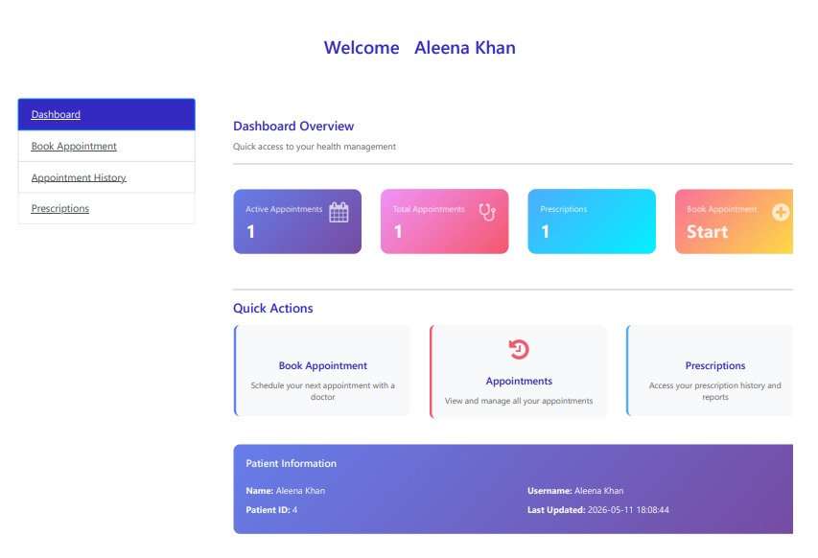
Figure 3.4: Patient Dashboard Interface

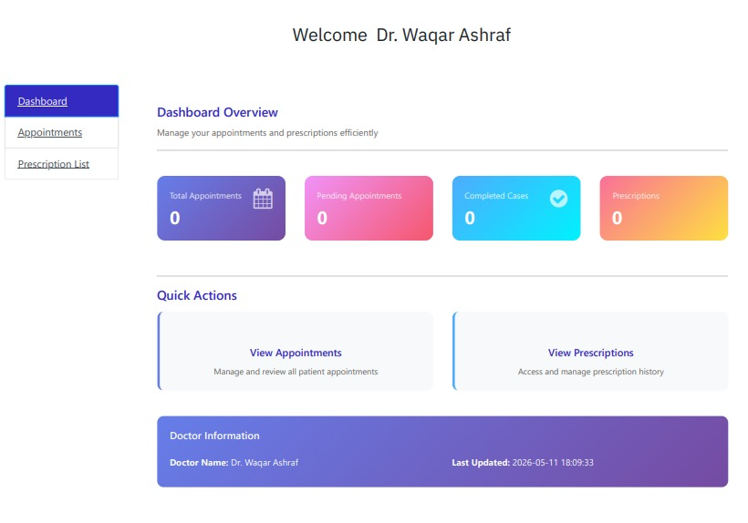
Figure 3.5: Doctor Dashboard Interface

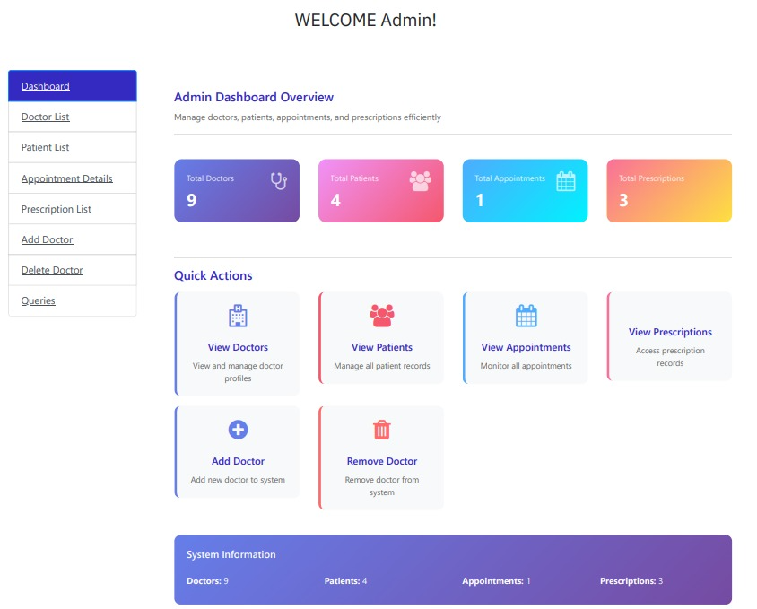
Figure 3.6: Admin Dashboard Interface

3.3 Logic / Backend Files:

- func.php — Patient Login Logic
Handles the patient login form submission. Checks the email and password against the patreg table. If correct, stores patient data in session variables (pid, username, fname, lname, gender, contact, email) and redirects to admin-panel.php.

- func1.php — Doctor Registration and Login Logic
Handles two things:
- Doctor registration — saves new doctor to doctb table with name, email, password, specialization, and fees
- Doctor login — checks username and password against doctb table. If correct, stores dname in session and redirects to doctor-panel.php

- func2.php — Patient Registration Logic
Handles patient registration form. Checks if password and confirm password match. Saves new patient to patreg table and sets session variables. Redirects to admin-panel.php after successful registration.

- func3.php — Admin Login Logic
Handles the receptionist login. Checks username and password against admintb table. If correct, stores username in session and redirects to admin-panel1.php.

- newfunc.php — Helper Functions File
Contains two important helper functions used across the system:
- display_docs(): fetches all doctors from doctb and prints them as HTML option elements for dropdown menus
- display_specs(): fetches all specializations and prints them as option elements for the specialization dropdown

3.4 Feature Pages:

- prescribe.php — Doctor Prescription Form
When a doctor clicks the Prescribe button for a patient appointment, they are taken to this page. It receives patient details (pid, ID, fname, lname, appdate, apptime) via GET parameters in the URL. The doctor fills in the disease, allergies, and prescription in text areas and submits the form. The data is saved into the prestb table.

- search.php — Doctor Patient Search
Used in the doctor panel navbar. The doctor can search for a patient by contact number. The system fetches matching appointments for that contact number under that doctor's name and displays the results in a styled table.

- appsearch.php — Receptionist Appointment Search
Used in the receptionist dashboard. When the receptionist searches by contact number, this page queries the appointmenttb table and displays matching appointment details including name, doctor, fees, date, time, and status.

- messearch.php — Receptionist Message Search
Used in the receptionist dashboard Queries section. Searches the contact table by phone number and displays the matching message details (name, email, contact, message).

- contact.php — Contact Form Handler
Processes the contact form submitted from contact.html. Takes name, email, phone, and message from the form and inserts them into the contact table in the database.

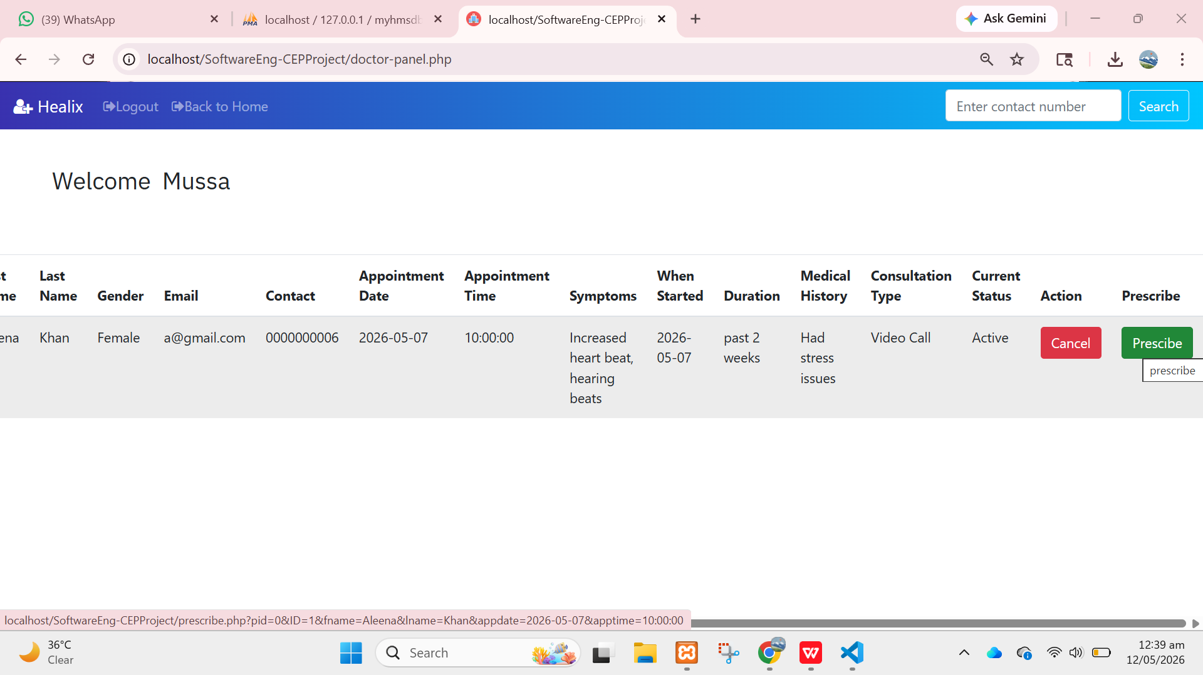
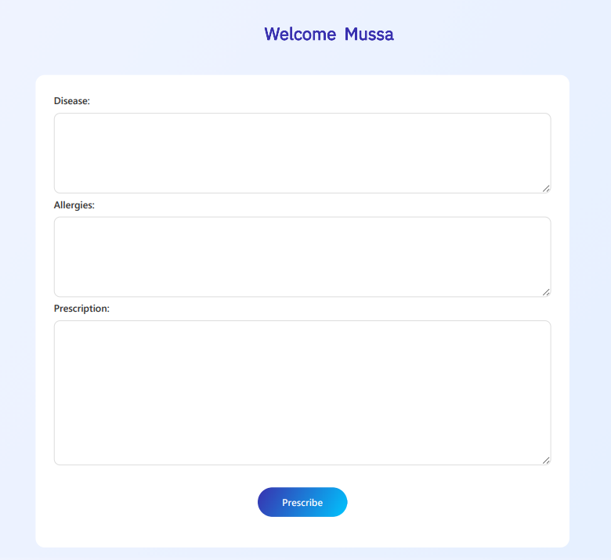

Figure 3.8: Prescription Form Page



Figure 3.9: Search Functionality Interface

3.5 Logout and Error Pages:

- logout.php — Patient Logout
Starts the session, calls session_destroy() to clear all session data, and redirects the user to index.php. Shows a "You have logged out" message with a link back to the login page.

- logout1.php — Doctor and Receptionist Logout
Same as logout.php but redirects to index.php (home page). Used by both doctors and receptionists to log out safely.

3.6 Error Page:

- error.php — Patient Login Error
Displayed when a patient enters an invalid email or password. Shows a styled error message with a "Try Again" button that links back to index1.php.

- error1.php — Password Mismatch Error
Displayed when a patient's confirm password does not match the password during registration. Shows an error message with a link back to index.php.

- error2.php — Doctor/Admin Login Error
Displayed when a doctor or admin enters invalid credentials. Shows an error message with a link back to index.php.

  Figure 3.10: Logout Page | 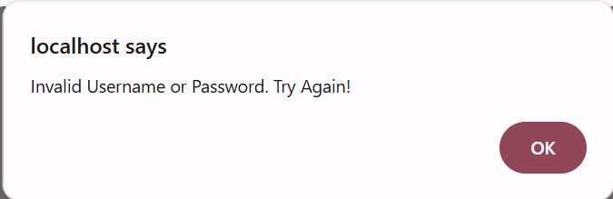  Figure 3.11: Login Error Page

- CHAPTER-04: SYSTEM FEATURES
4.1 Patient Features

- Registration and Login

- Patient registers with first name, last name, email, phone, gender, and password
- Password and confirm password must match
- Login using email and password
- Session stores pid, username, fname, lname, gender, contact, email

- Book Appointment

- Select specialization to filter doctors
- Select doctor — consultation fee fills automatically
- Choose appointment date and time (from fixed time slots)
- Fill in symptoms, when symptoms started, duration in days
- Enter previous medical condition (optional)
- Upload an image (optional)
- Choose consultation type: In-clinic, Call, or Video Call
- System checks if selected time slot is already booked
- System checks that date and time are in the future

- Appointment History
- View all past and current appointments
- See doctor name, fees, date, time, symptoms, consultation type, status
- Cancel an active appointment

Prescriptions
- View prescriptions written by doctor
- See disease, allergies, and prescription details
- Pay bill and generate PDF report

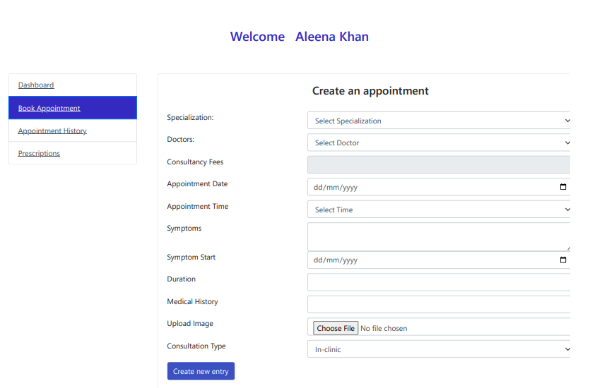
Figure 4.1: Appointment Booking Form

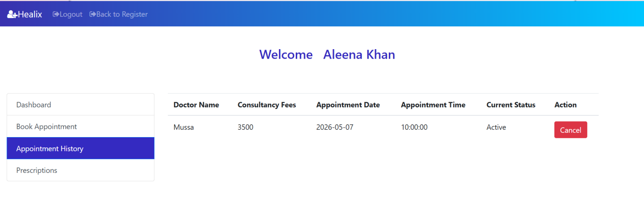
Figure 4.2: Appointment History Page

4.2 Doctor Features

- Appointments

- View all appointments booked with that doctor
- See full patient details: name, gender, email, contact
- See all symptom information: symptoms, when started, duration, previous condition, consultation type
- Cancel an appointment
- Click Prescribe button to write prescription for a patient

- Prescription List

View all prescriptions written for all patients
See disease, allergy, and prescription details per patient

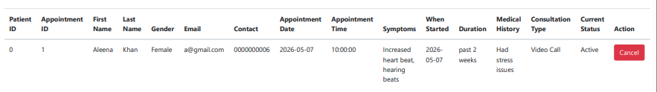
Figure 4.3: Doctor Appointment Panel

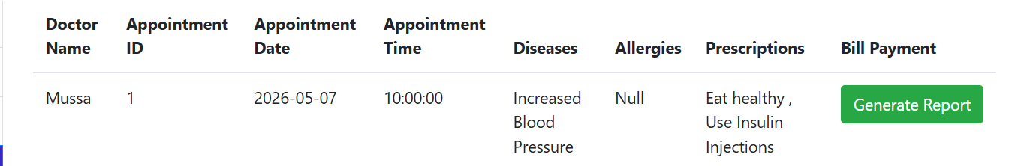
Figure 4.4: Doctor Prescription List

4.3 Admin Features:

- Doctor Management
- View full doctor list with name, specialization, email, fees
- Add new doctor with name, specialization, email, password, fees
- Delete a doctor by email

- Patient Management
- View all registered patients with full details
- Search patient by contact number

- Appointment Management
- View all appointments from all patients and doctors
- See appointment status (Active, Cancelled by Patient, Cancelled by Doctor)
- Search appointments by contact number

- Prescription List
- View all prescriptions from all doctors

- Queries
- View all contact form messages from patients or visitors
- See name, email, contact, and message

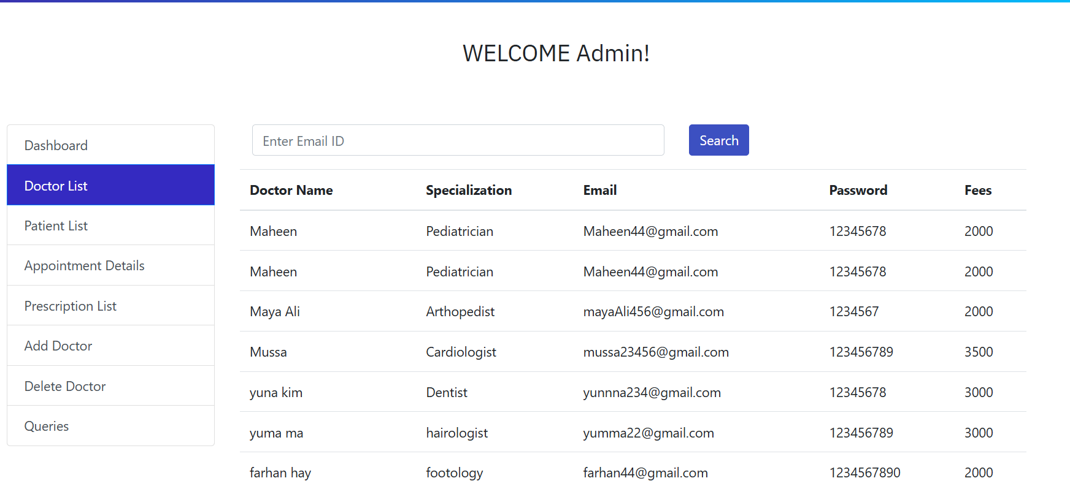
Doctor List

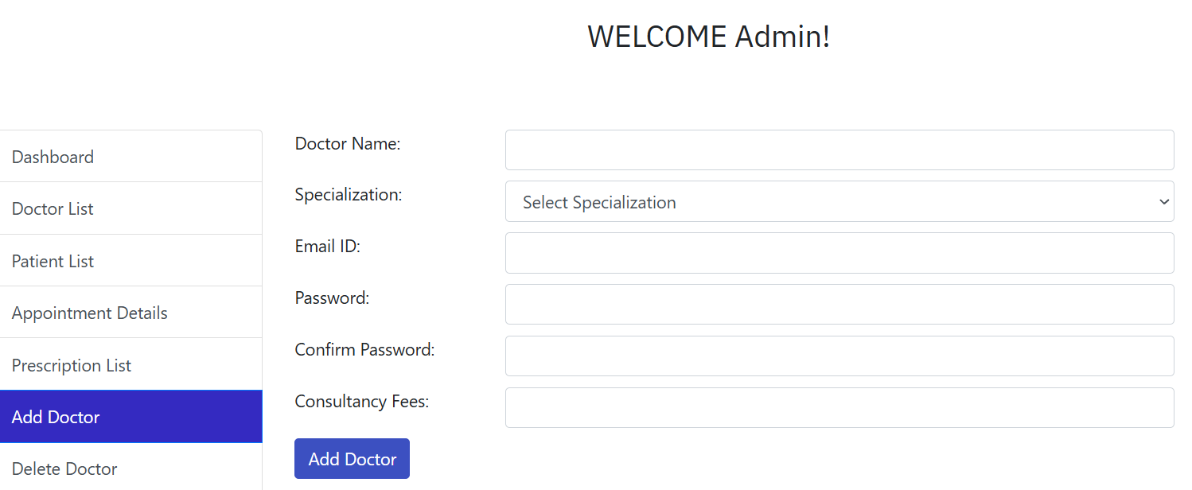
Add Doctor

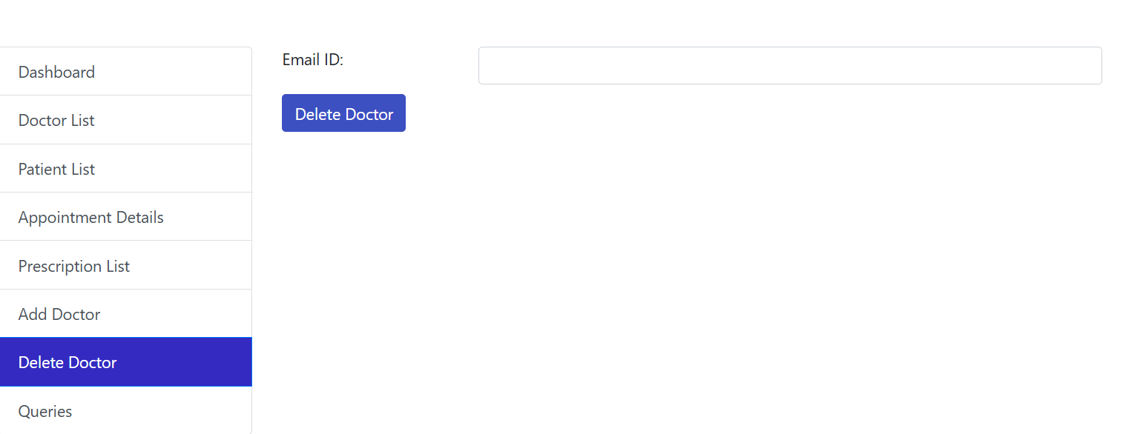
Delete Doctor

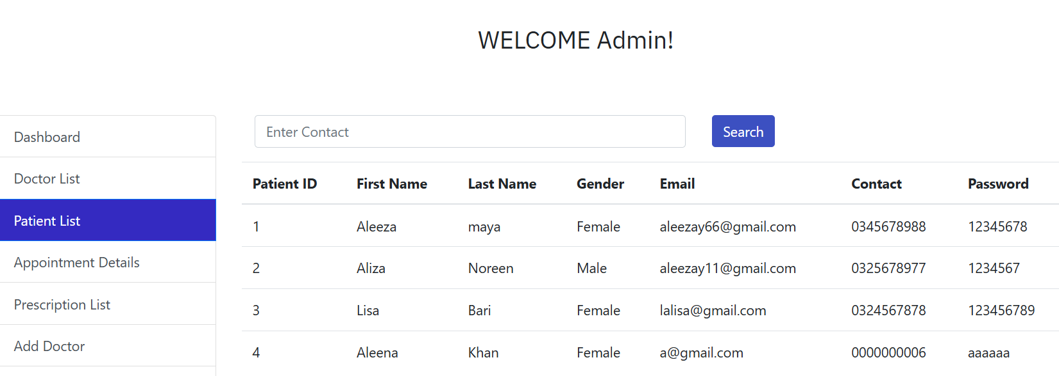
Patient List

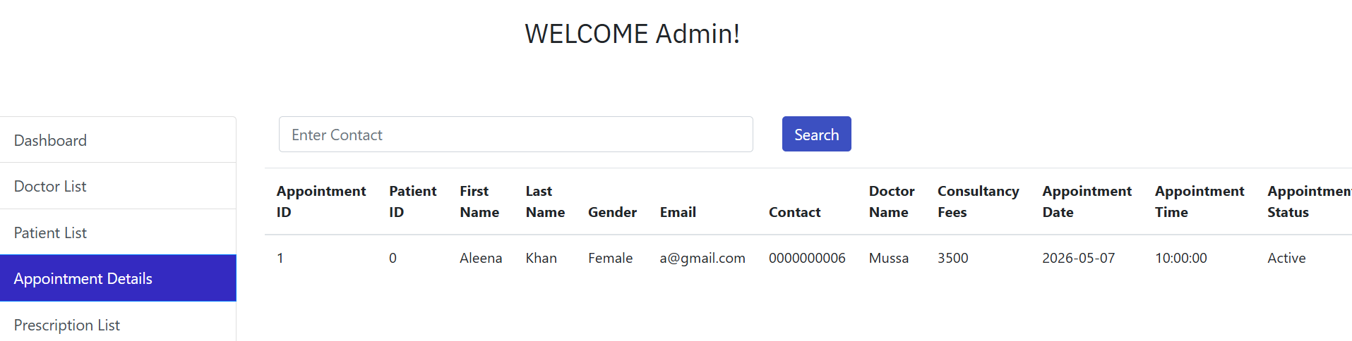
Appointment List
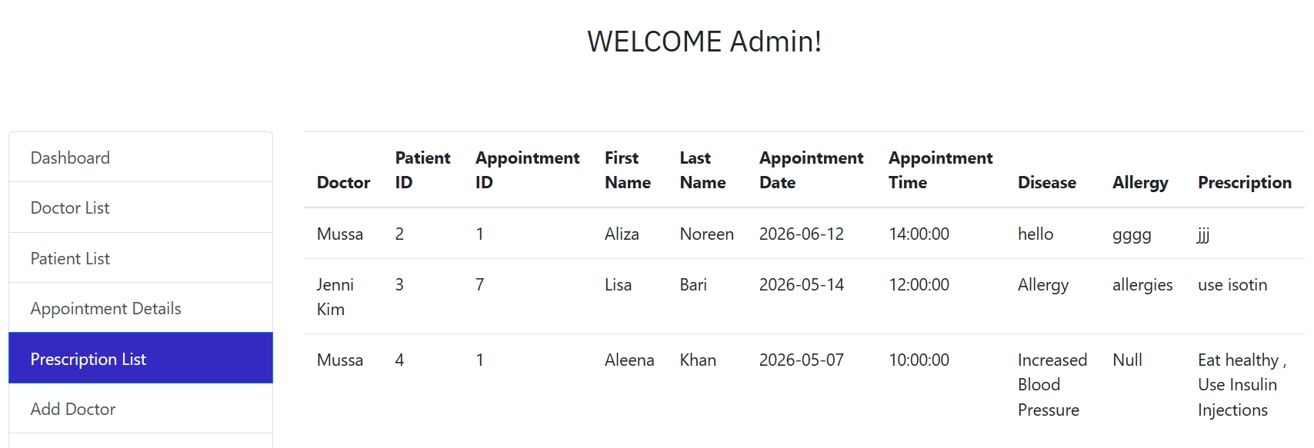
Prescription List


Add Doctor
Figure 4.5: Admin Doctor Management

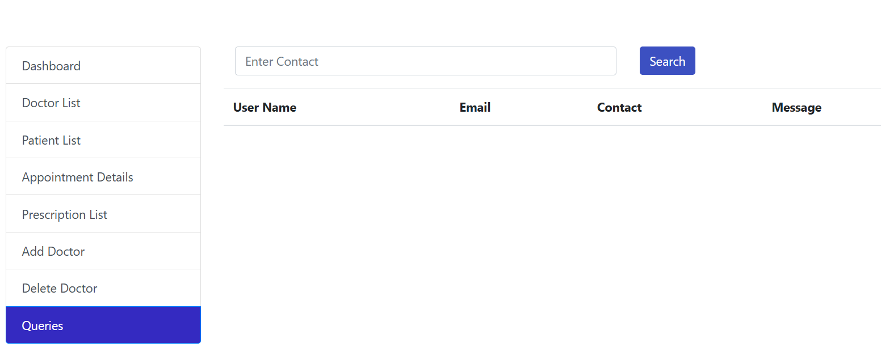
Figure 4.6: Queries Management Page

- CHAPTER-05: SYSTEM WORKING
5.1 Appointment Booking Logic:

When a patient books an appointment, the following checks are performed:

1. Check if the appointment date is today or in the future
2. If the date is today, check if the appointment time is still in the future
3. Check if the selected doctor already has an appointment at that date and time
4. If all checks pass, insert the appointment into the database
5. If the time slot is already taken, show an alert to choose a different time

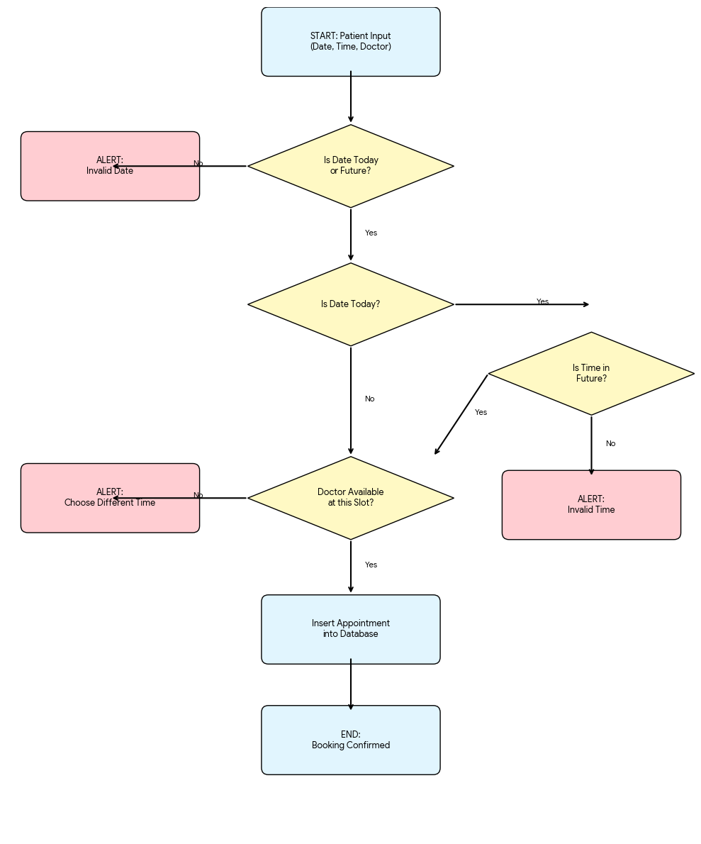
Figure 5.1: Appointment Booking Workflow/Flowchart ER Diagram

5.3 PDF Report Generation:

The system uses the TCPDF library to generate a professional PDF report.

The bill includes:
- Patient ID and Appointment ID
- Patient full name, phone number, email
- Doctor name, appointment date and time
- Consultation type
- Disease, allergies, and prescription
- Hospital footer with contact information
The bill is triggered when the patient clicks "Pay Bill" in the Prescriptions tab. The PDF opens directly in the browser.

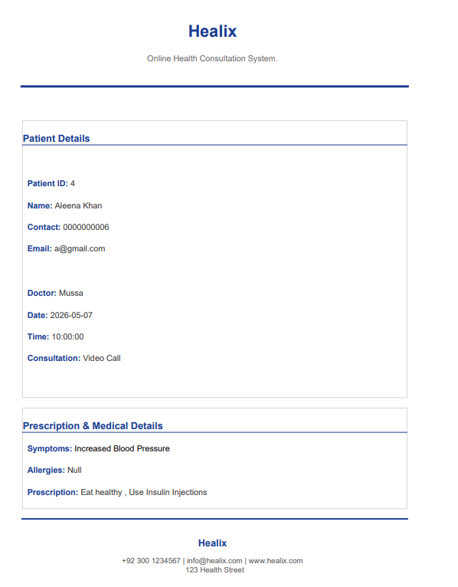
Figure 5.2: Generated Patient Report

5.4 Session Management:

Each user type uses PHP sessions to store login data.

- Patient Session Variables:
- $_SESSION['pid'] — Patient ID
- $_SESSION['username'] — Full Name
- $_SESSION['fname'], $_SESSION['lname'] — First and Last Name
- $_SESSION['gender'], $_SESSION['contact'], $_SESSION['email']

- Doctor Session Variables:
- $_SESSION['dname'] — Doctor's username (full name)

- Receptionist Session Variables:
- $_SESSION['username'] — Receptionist username

- Logout:
- Both logout.php and logout1.php call session_destroy() to completely clear the session
- User is redirected to index.php after logout

- CHAPTER-06: SECURITY & FUTURE IMPROVEMENTS

6.1 Security Notes and Known Limitations:
The following issues exist in the current version and should be fixed before production use:
1. SQL Injection — The system uses direct string interpolation in SQL queries. Prepared statements should be used instead.
2. Plain Text Passwords — Passwords are stored in plain text. They should be hashed using PHP's password_hash() function.
3. No Login Protection — Dashboard pages do not check if a user is logged in. Session checks should be added at the top of each dashboard file.
4. Duplicate Doctor Names — The doctb table has duplicate entries for some doctors. A UNIQUE constraint should be added to the email column.
5. Patient ID After Registration — The pid is not always correctly set in the session after registration.

6.2 Future Improvements:

- Add password hashing for secure login
- Add session protection on all dashboard pages
- Add email notifications for appointment confirmation
- Add a search feature for prescriptions
- Add a report/statistics page for the receptionist
- Make the system mobile responsive for smaller screens
- Add online payment integration for bill payments
- Add the ability for doctors to update or delete prescriptions

- CHAPTER-07: CONCLUSION
7.1 Conclusion:

The Online Health Consultation System A.K.A “Healix” successfully provides a complete digital solution for managing hospital operations. It covers the full workflow from patient registration to prescription and report generation.

The three-role system (Patient, Doctor, Admin) ensures proper access control and a smooth user experience for each type of user.

